**Common commands**

**ubuntu@ip-172-31-10-134:~$ man cat**

(cat stands for concatenate. To concatenate something is to link or chain parts together. cat streams or prints the output of whatever file you ask for to the Terminal.)

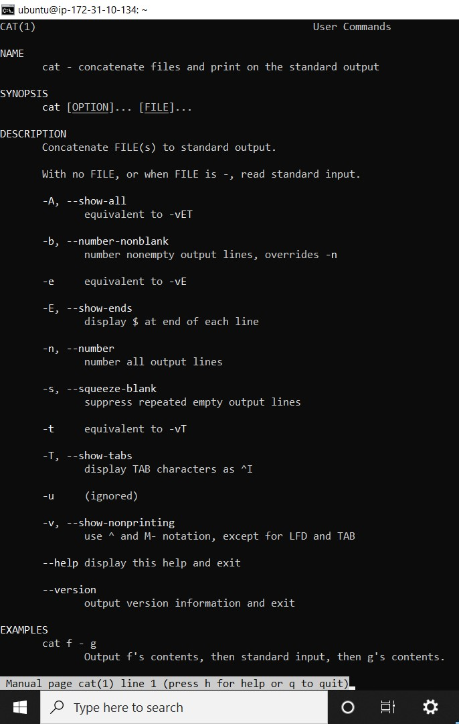

**ubuntu@ip-172-31-7-93:~$ sudo cat /var/log/auth.log**

**(**To use cat, type cat followed by the file you want to look at:)

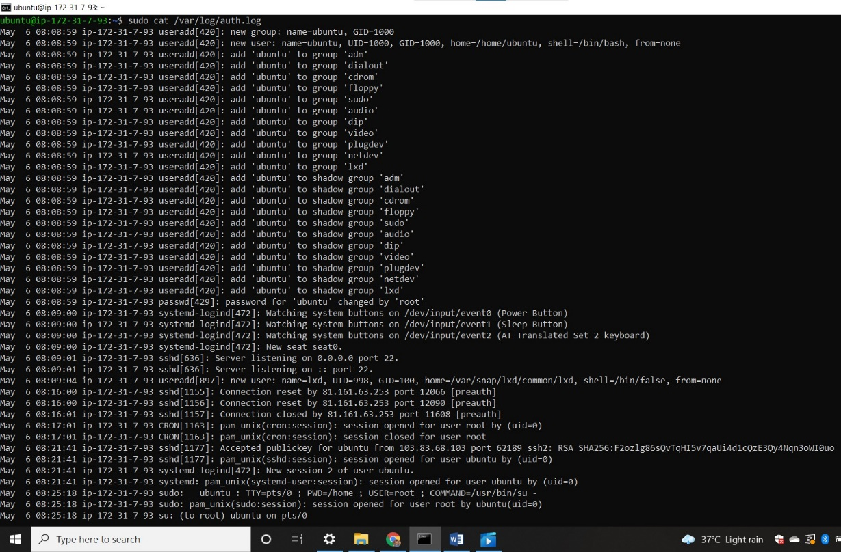

**ubuntu@ip-172-31-7-93:~$ sudo head /var/log/auth.log**

**( we use head command to Show’s the top first several lines of the file you specify (10 lines by default).**

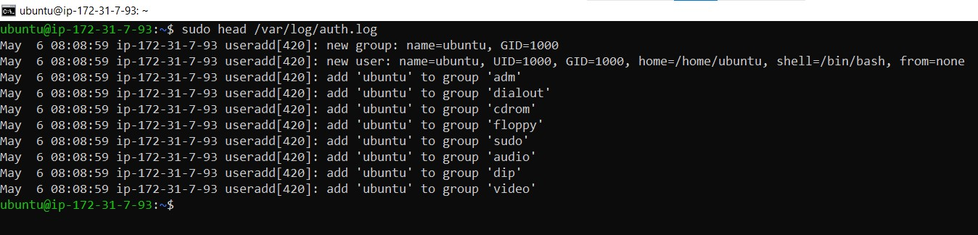

**ubuntu@ip-172-31-7-93:~$ sudo head -20 /var/log/auth.log**

**(If we want to see the first 20 lines of the file so we can write this code.)**

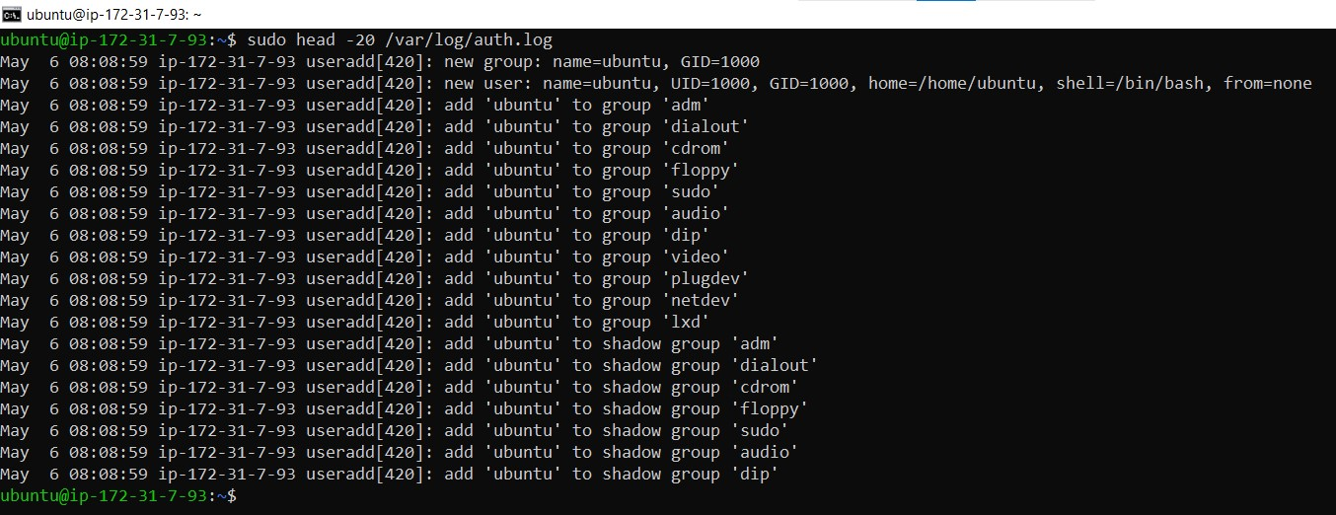

**ubuntu@ip-172-31-7-93:~$ sudo tail /var/log/auth.log**

**( we use tail command to Show’s the bottom several lines of the file you specify (10 lines by default).**

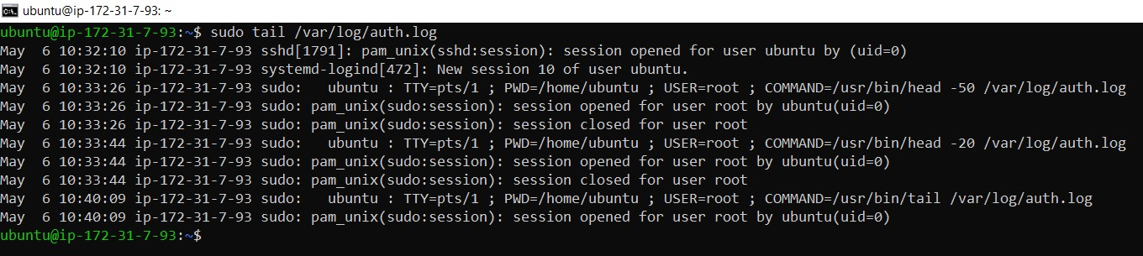

**ubuntu@ip-172-31-7-93:~$ sudo tail -20 /var/log/auth.log**

**(If we want to see the bottom 20 lines of the file so we can write this code.)**

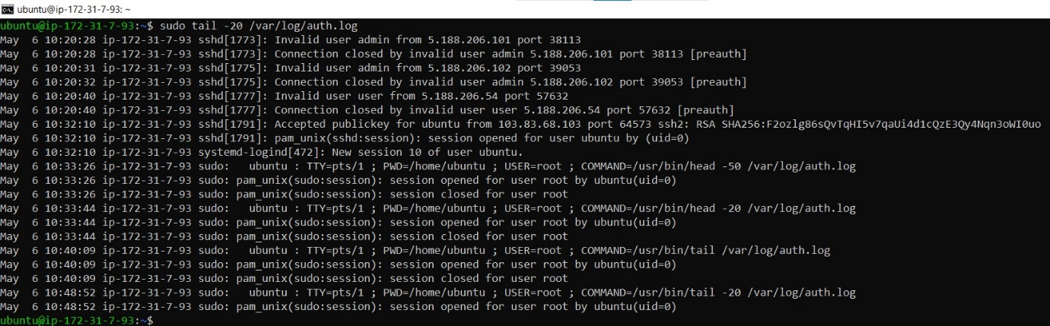

**ubuntu@ip-172-31-7-93:~$ pwd**

*/home/ubuntu*

**( if we want to see our present working directory we write this command.)**

**ubuntu@ip-172-31-7-93:~$ man pwd**

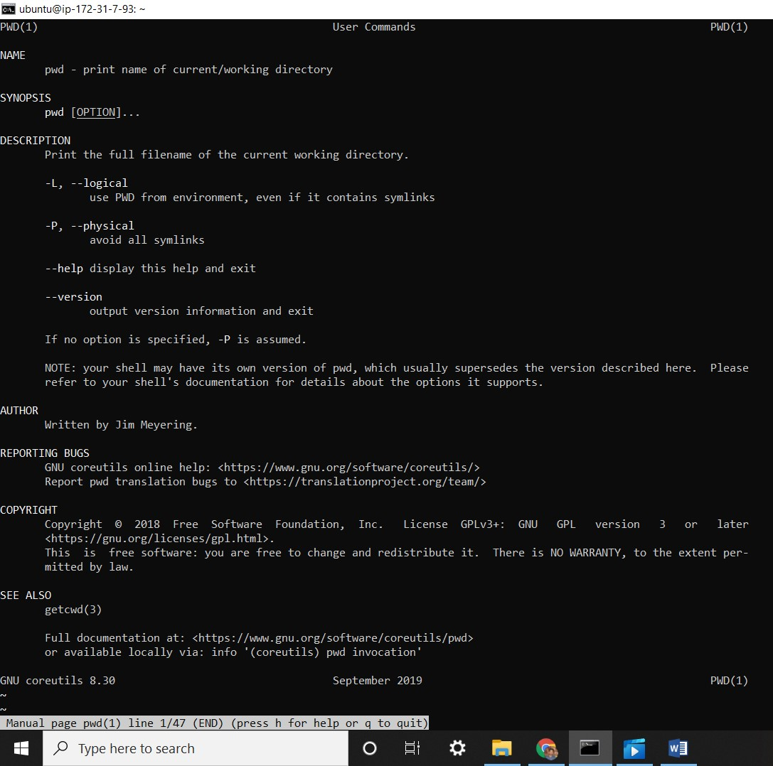

**ubuntu@ip-172-31-7-93:~$ cd /**

**ubuntu@ip-172-31-7-93:/$ ls**

bin boot dev etc home lib lib32 lib64 libx32 lost+found media mnt opt proc root run sbin snap srv sys tmp usr var

**ubuntu@ip-172-31-7-93:/$ cd /etc/**

**ubuntu@ip-172-31-7-93:/etc$ cd /etc/**

**ubuntu@ip-172-31-7-93:/etc$ cd /etc/skel/**

**ubuntu@ip-172-31-7-93:/etc/skel$ pwd**

/etc/skel

**ubuntu@ip-172-31-7-93:/etc/skel$**

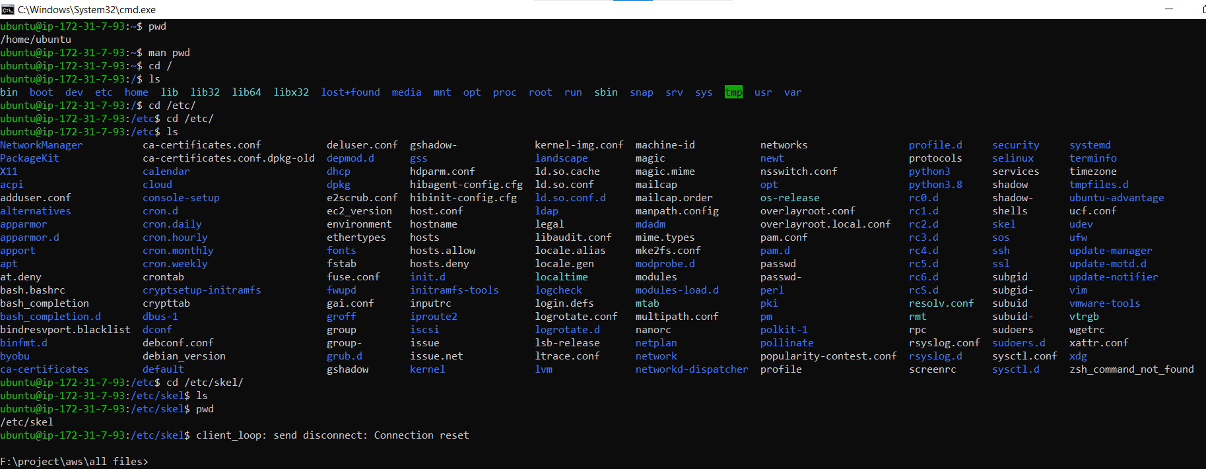

**ubuntu@ip-172-31-7-93:/etc$ cd ~**

**ubuntu@ip-172-31-7-93:~$**

**[if you want to come with home directory or back put (cd ~ )command.]**

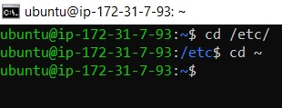

**ubuntu@ip-172-31-7-93:~$ pwd**

**/home/Ubuntu**

**(present working directory)**

**ubuntu@ip-172-31-7-93:~$ cd /var/log**

**(change directory)**

**ubuntu@ip-172-31-7-93:/var/log$**

**ubuntu@ip-172-31-7-93:/var/log$ ls**

amazon apt auth.log btmp cloud-init-output.log cloud-init.log dist-upgrade dmesg dpkg.log journal kern.log landscape lastlog private syslog unattended-upgrades wtmp

**ubuntu@ip-172-31-7-93:/var/log$ ls –alh**

**(when we run this command we see all files are in list format )**

**ubuntu@ip-172-31-7-93:/var/log$ ls -al**

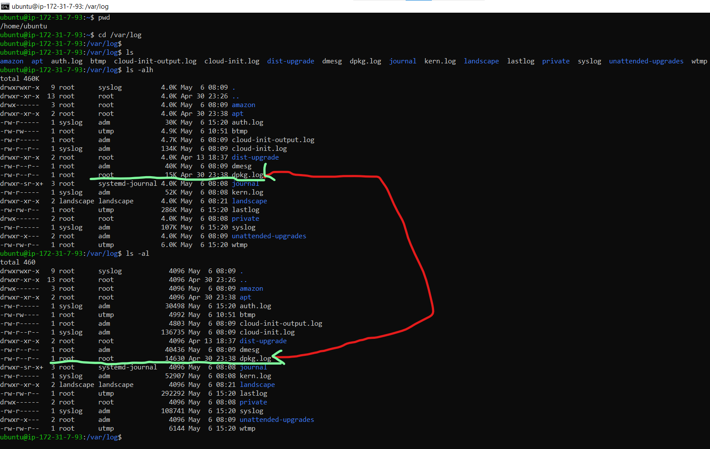

**ubuntu@ip-172-31-7-93:~$ ll –h**

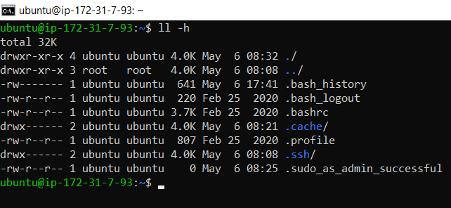

**ubuntu@ip-172-31-7-93:~$ man find**

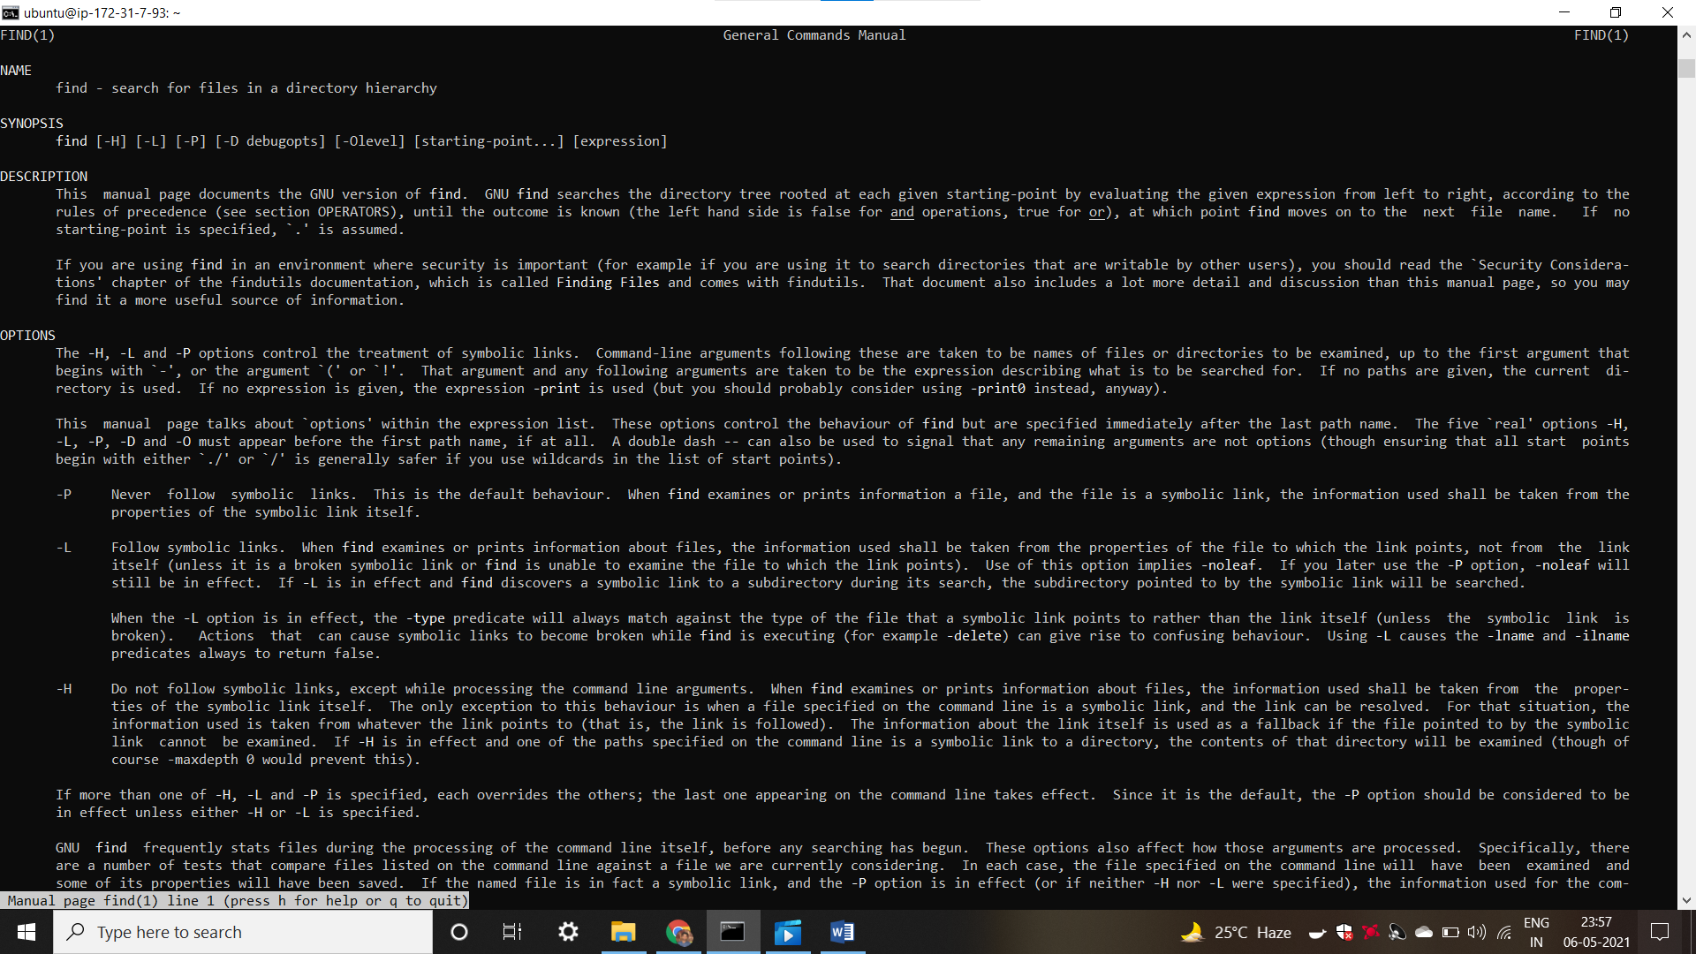

**ubuntu@ip-172-31-7-93:~$ find / -name auth.log**

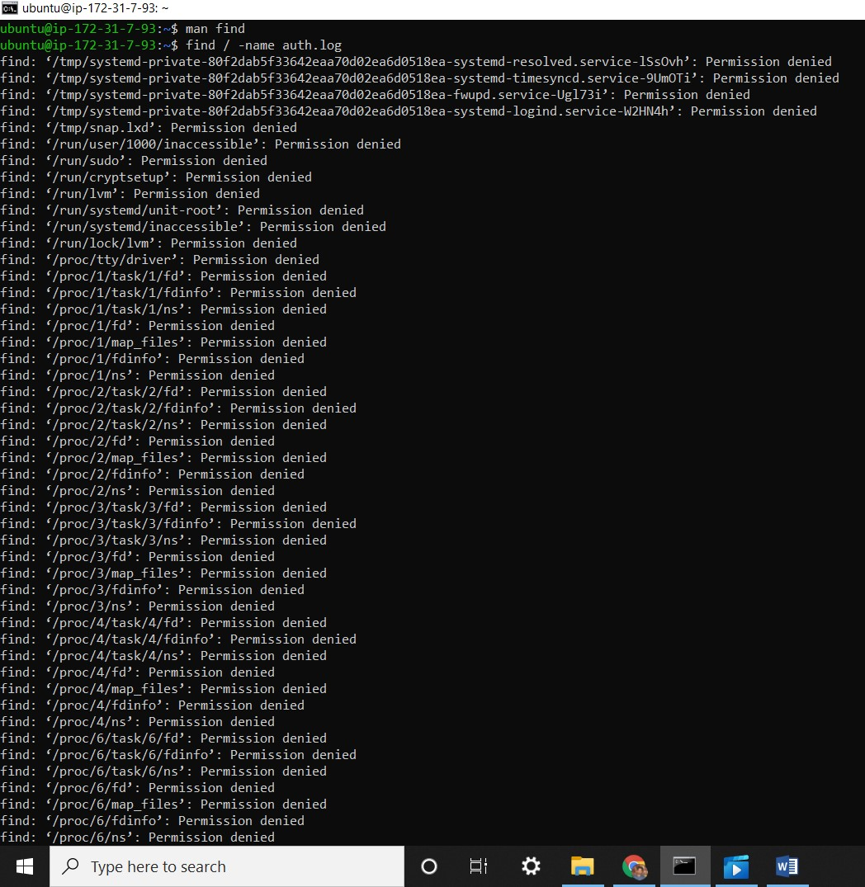

**ubuntu@ip-172-31-7-93:~$ sudo find / -name auth.log**

/var/log/auth.log

**ubuntu@ip-172-31-7-93:~$** sudo find / -name auth*

(we use * command to find file all details)

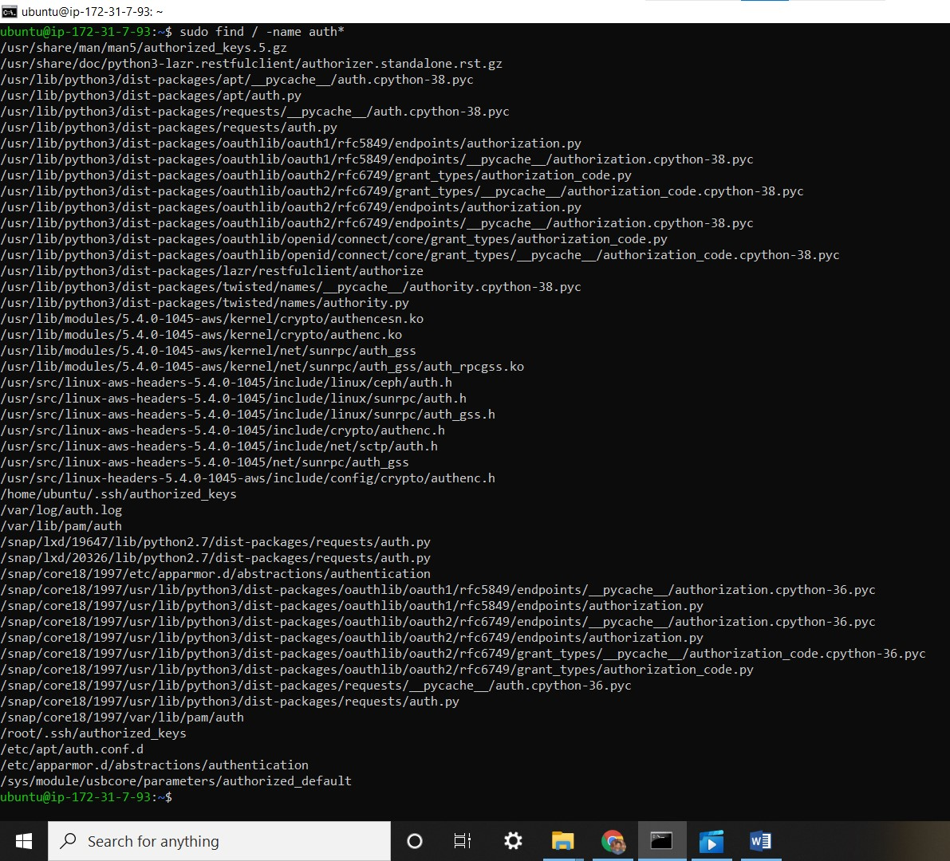

**ubuntu@ip-172-31-7-93:~$ sudo updatedb**

sudo: updatedb: command not found

(Sudo updated command means we update our database, but we have not a database installed, so firstly we installed database then again put command **sudo updatedb** )

**ubuntu@ip-172-31-7-93:~$ updatedb**

*Command 'updatedb' not found, but can be installed with:*

sudo apt install mlocate # version 0.26-3ubuntu3,

or

sudo apt install locate # version 4.7.0-1ubuntu1

**ubuntu@ip-172-31-7-93:~$ sudo apt install mlocate**

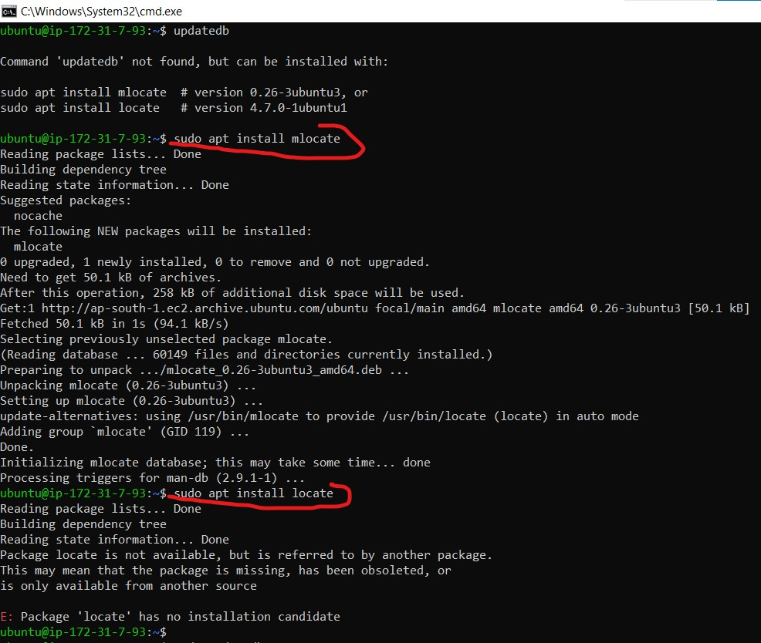

**(Now our data-base has been installed)**

**ubuntu@ip-172-31-7-93:~$ sudo cat /var/log/auth.log**

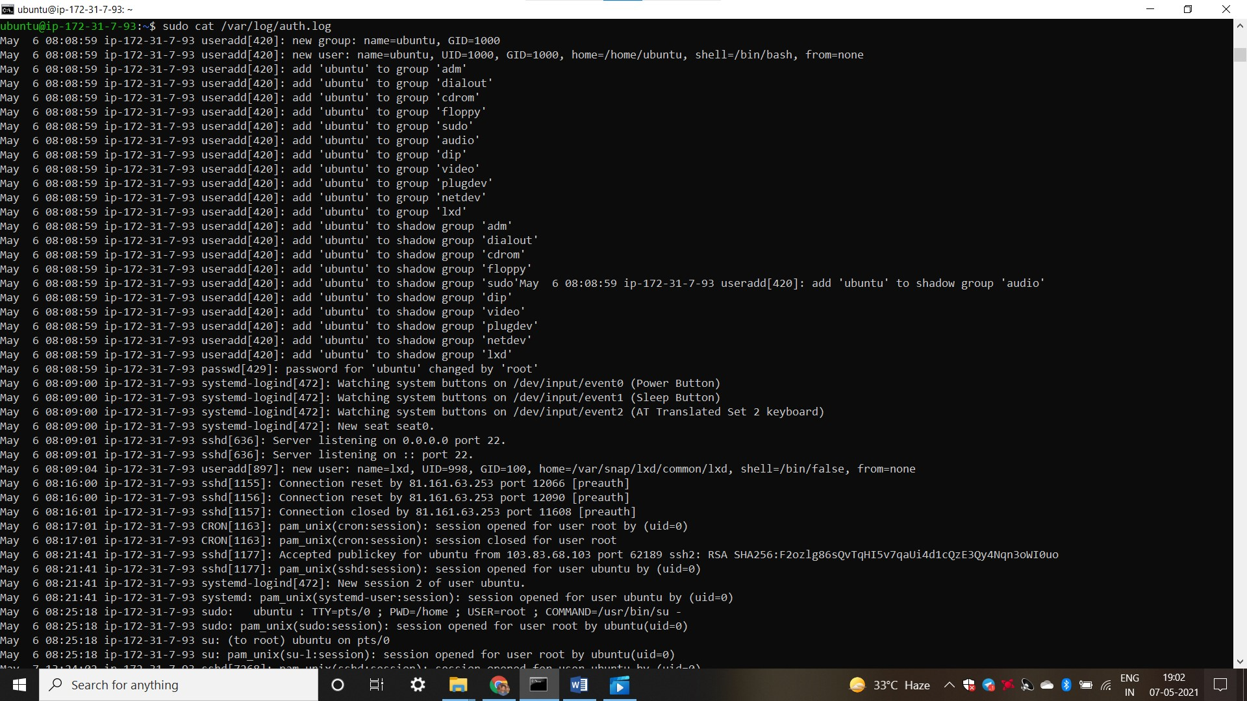

**Grep:-**

**grep stands for global regular expression print. You tell grep what to search for and the directory or file to search, and it prints all of the lines that have a match.**

**ubuntu@ip-172-31-7-93:~$ sudo grep opened /var/log/auth.log**

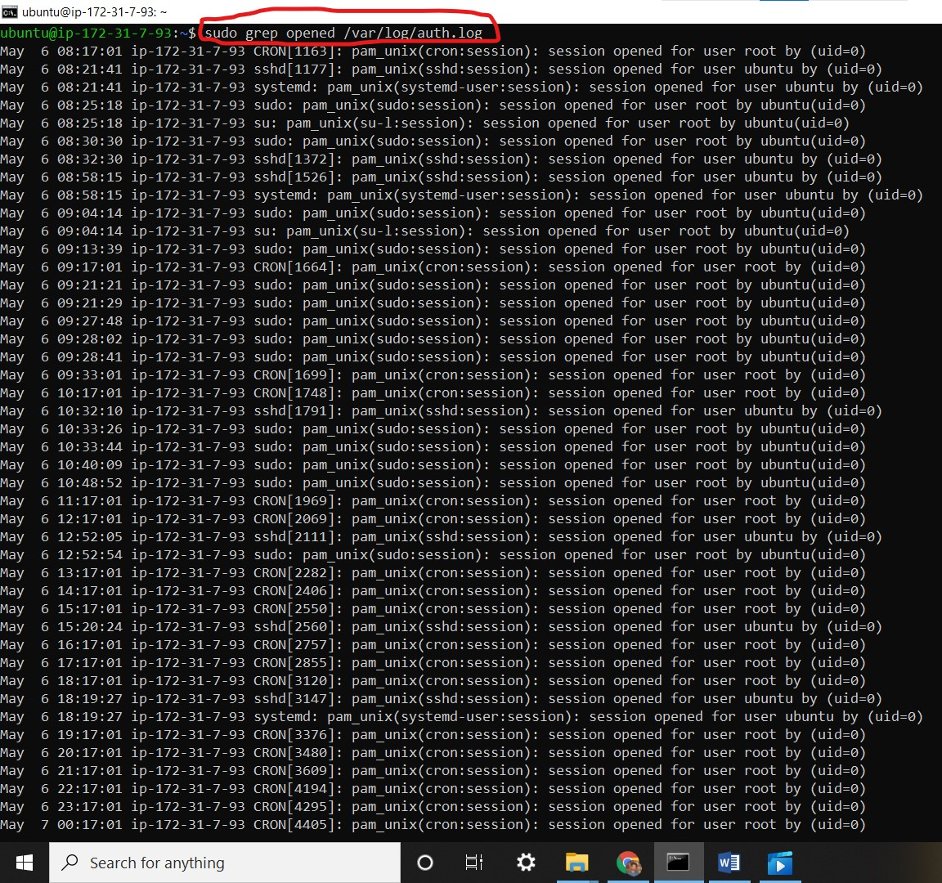

**more :-**

**more - Lets you pipe output from another command (like cat) into it so you can scroll around in it and look at things.**

**->Press U to up press D to down.**

**ubuntu@ip-172-31-7-93:~$ man more**

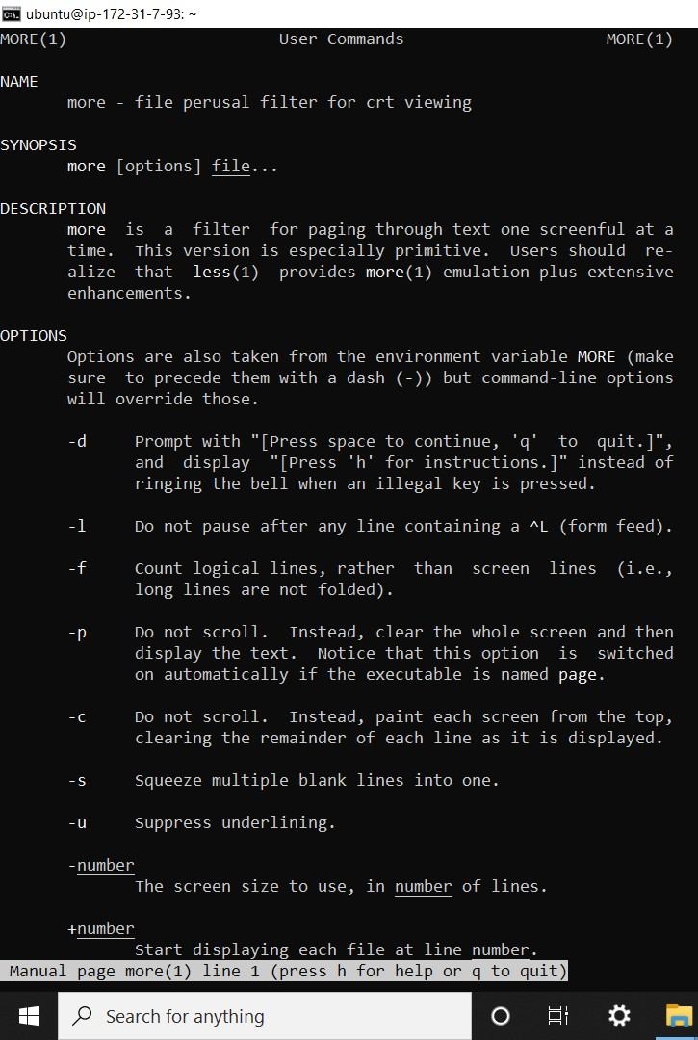

**less**

**less - It was supposed to be an improved version of more, but now they’re quite similar. However, more does let you use your arrow keys to scroll, which I really like.**

**ubuntu@ip-172-31-7-93:~$ sudo grep opened /var/log/auth.log | less**

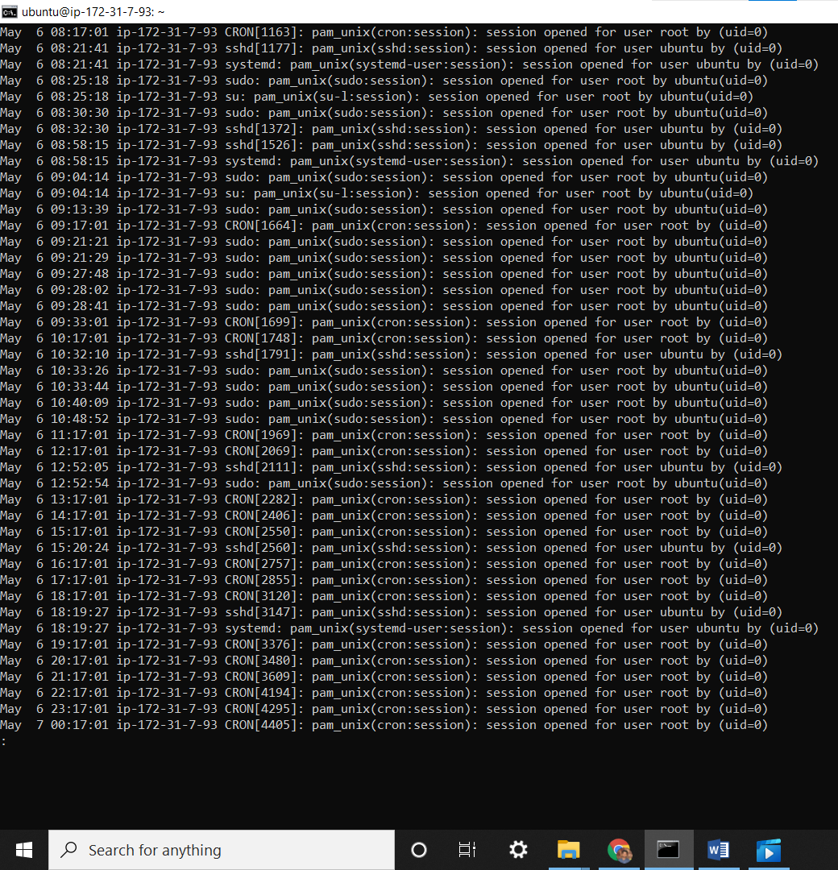

**touch**

**touch - Although its intended purpose is to change the modification date of a file, it can also be used to quickly and easily create an empty file of the name you specify. That’s a lot to take in in one lesson! Please practice each command, navigating around your Ubuntu system and looking at things. If you don’t know where to start, /var/log is a good place. You’ll have to use sudo privileges to look at some of the files there. Bear in mind, there are entire lessons coming up on some of these commands, like grep. You don’t have to be expert with these yet. Just familiar**

**ubuntu@ip-172-31-7-93:~$ man touch**

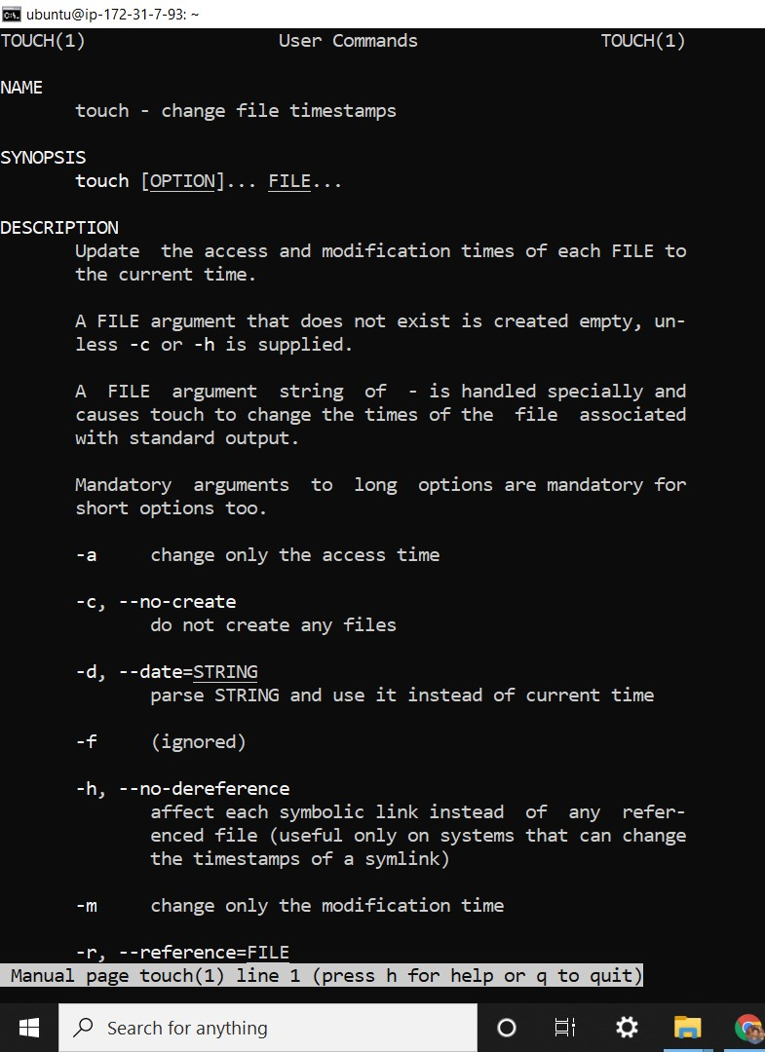

**ubuntu@ip-172-31-7-93:~$ pwd**

/home/Ubuntu

(my present working directory)

**ubuntu@ip-172-31-7-93:~$ ls (No files come in ls command)**

**ubuntu@ip-172-31-7-93:~$ touch test1**

**(create a file name is test1)**

**ubuntu@ip-172-31-7-93:~$ ls**

test1

(file has been created)

**ubuntu@ip-172-31-7-93:~$ rm * (this remove file )**

**ubuntu@ip-172-31-7-93:~$ ls**

**(no file come because previously we use rm command )**

**ubuntu@ip-172-31-7-93:~$ touch file1**

**ubuntu@ip-172-31-7-93:~$ ls**

file1

**ubuntu@ip-172-31-7-93:~$ touch file2 file3 file4**

**ubuntu@ip-172-31-7-93:~$ ls**

file1 file2 file3 file4

**ubuntu@ip-172-31-7-93:~$ ll**

total 32

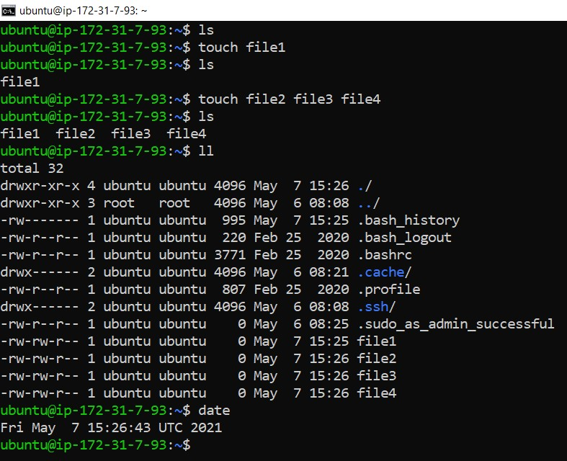

**ubuntu@ip-172-31-7-93:~$ date**

Fri May 7 15:26:43 UTC 2021